Sinh Viên : Vũ Văn Trọng - 20184206

**Assignment 2**

.data

A: .word 7, -2, 5, 1, 5,6,7,3,6,8,8,59,5

Aend: .word

.text

main: la $a0,A #$a0 = Address(A[0])

la $a1,Aend

addi $a1,$a1,-4 #$a1 = Address(A[n-1])

j sort #sort

after_sort:

li $v0, 10 #exit

syscall

end_main:

#--------------------------------------------------------------

sort:

beq $a0,$a1,done #single element list is sorted

j max #call the max procedure

after_max:

lw $t0,0($a1) #load last element into $t0

sw $t0,0($v0) #copy last element to max loca

sw $v1,0($a1) #copy max value to last elemen

addi $a1,$a1,-4 #decrement pointer to last ele

j sort #repeat sort for smaller list

done: j after_sort

#-----------------------------------------------------------------

max:

addi $v0,$a0,0 #init max pointer to first element

lw $v1,0($v0) #init max value to first value

addi $t0,$a0,0 #init next pointer to first

loop:

beq $t0,$a1,ret #if next=last, return

addi $t0,$t0,4 #advance to next element

lw $t1,0($t0) #load next element into $t1

slt $t2,$t1,$v1 #(next)<(max) ?

bne $t2,$zero,loop #if (next)<(max), repeat

addi $v0,$t0,0 #next element is new max element

addi $v1,$t1,0 #next value is new max value

j loop #change completed; now repeat

ret:

j after_max

* ***Bảng Register***

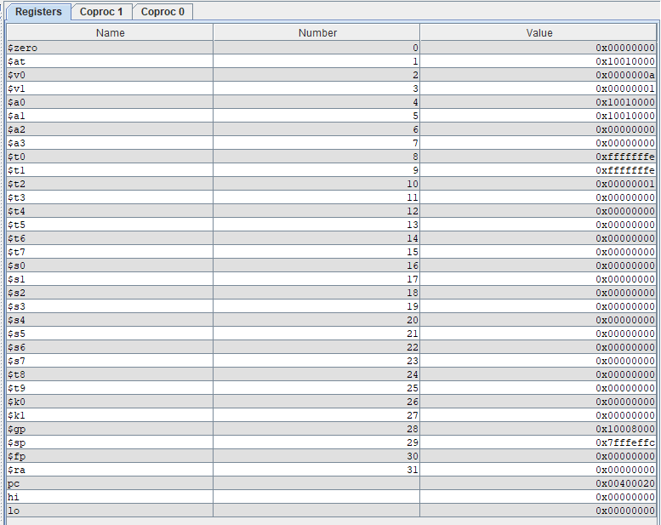

* ***Bảng Data Segment trước:***

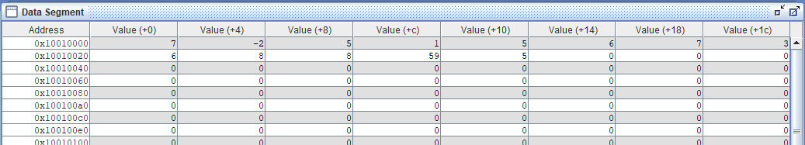

* ***Bảng DataSegment sau :***

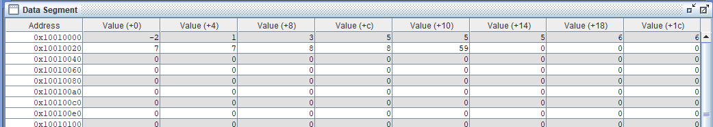

* Ta thấy Mảng A đã được sắp xếp đúng